Ballydesmond NS
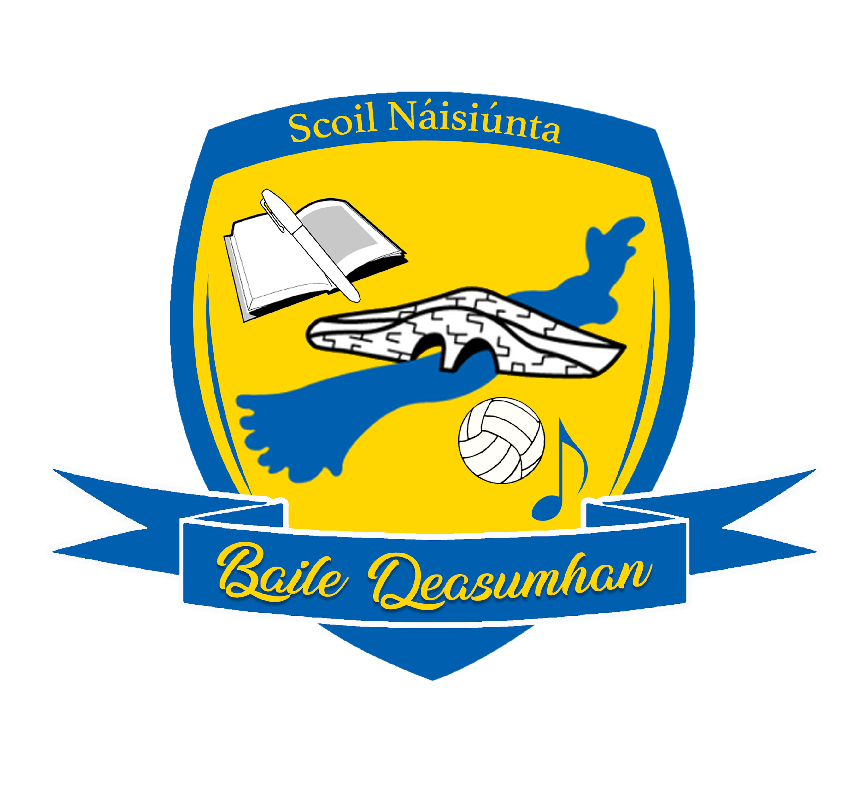

Covid-19 Policy

COVID 19
Policy Statement
Ballydesmond NS is committed to providing a safe and healthy workplace for all our staff and a safe learning environment for all our pupils. To ensure that, we have developed the following COVID- 19 Response Plan. The BOM and all school staff are responsible for the implementation of this plan and a combined effort will help contain the spread of the virus. We will:
• Continue to monitor our COVID-19 response and amend this plan in consultation with our staff
• Provide up to date information to our staff and pupils on the Public Health advice issued by the HSE and Gov.ie
• Display information on the signs and symptoms of COVID-19 and correct hand-washing techniques
• Inform all staff and pupils of essential hygiene and respiratory etiquette and physical distancing requirements
• Adapt the school to facilitate physical distancing as appropriate in line with the guidance and direction of the Department of Education and Skills
• Keep a contact log to help with contact tracing
• Ensure staff and pupils engage with the induction / familiarisation briefing provided by the Department of Education and Skills
• Implement the agreed procedures to be followed in the event of someone showing symptoms of COVID-19 while at school
• Provide instructions for staff and pupils to follow if they develop signs and symptoms of COVID-19 during school time
• Implement cleaning in line with Department of Education and Skills advice
All school staff will be consulted on an ongoing basis and feedback is encouraged on any concerns, issues or suggestions. This can be done through the Lead Worker Representative(s) (Ella O’ Sullivan & Mary Breen)
Signed: Pat Neenan Date: 17/08/20

